Poly Hockey
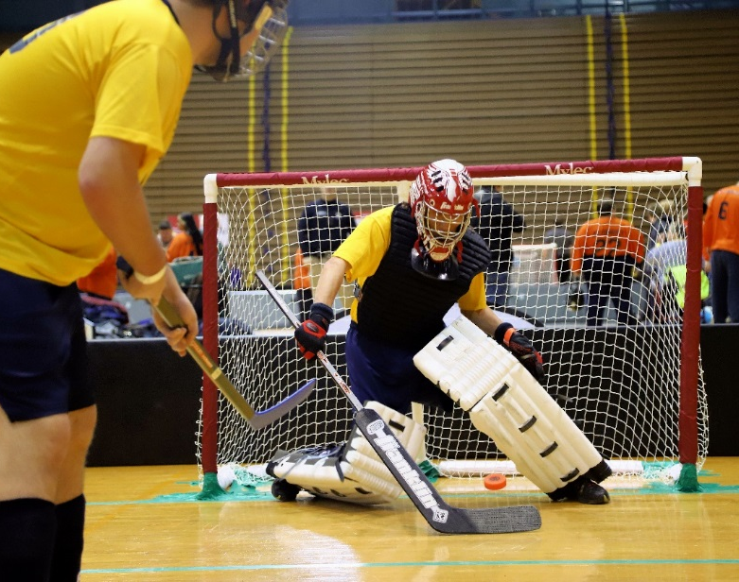

SOMI-Specific Information

Sport season:
September - November

Culminating State Events:
State November Classic

Events Offered:
Team Competition
Individual Skills Contest
Unified Team Competition
*Unified follows the same rules as traditional competition

National Governing Body:
Special Olympics Michigan
Central Michigan University
Mt. Pleasant, MI 48859
(800) 644-6404

Uniform Guidelines

- All players must wear uniforms that are identical in color and style.
- Uniforms must have large, identifiable numbers on the front and back or on the back and sleeves.
- Protective shin guards or shin socks must be worn by all players. Shin guards must be worn under socks (soccer style) and cannot exceed 12 inches.
- All athletes must wear a hockey style helmet with a facemask. Helmets no longer need an HECC certification but must include a chinstrap and be securely fastened at all times. Skills athletes must also wear a helmet; however, they do not need facemasks.
- All players on the players’ bench and the penalty bench must wear the protective helmet/facemask while in the bench area. For a violation of this rule, after a warning by the Referee, a misconduct penalty for an equipment violation shall be assessed to the offending player.
- Proper running shoes must be worn by all persons on the playing surface during play.
- Optional equipment for general players may include elbow pads, mouth guards, knee pads, and protective cups and gloves.
- The goalkeeper must wear a face mask with helmet and a dangling throat protector, or a Velcro throat protector wrapped with a hard plastic insert. The goalkeeper must wear a team uniform shirt.
- Optional equipment for goalkeeper may include catching glove, blocking pads, mouth guard and protective cup. A goalkeeper may wear regulation-size ice hockey goalkeeper pads and gloves or similar protective gear (i.e., street hockey pads, cricket pads, baseball glove). If a chest protector is worn it must be worn underneath the uniform so the number of the jersey can clearly be seen.
- The leg guards worn by goalkeepers must not exceed 12 inches in extreme width when on the player's leg. Excessive shin pads and blocking pads are not allowed. Manufactured shin pads and blocking pads are acceptable, but no modifications to enhance the blocking surface are permitted.
- For Unified Sports teams the athlete should have even numbered uniforms and the partner odd numbered.
- Hats, bandanas, du-rags, jewelry, and denim may not be worn during games or practice. Headbands, wristbands, and arm sleeves are acceptable. Headwear for religious or medical reasons are acceptable but must be brought to the attention of the Games Director prior to competition.

Team Size
- A team roster shall consist of at least a minimum of seven players and not more than 13 players. A team may not start a game with less than six players. If a team does not have six players present for the first game, it is a forfeit, and, regardless of the outcome of their first game, their second game will be against the losing team of the other bracket in their division. A team may start the second game with five players, if a player is lost to injury or illness on site. If during the game a team has less than five players, the game is stopped and a forfeit declared.
- There are no restrictions on the number of lines an athlete can play. Any player can be substituted at any stoppage of play and can play any position. SOMI's philosophy is that each player is equal and deserves recognition.
- Each coach must see to it that each athlete has frequent opportunities to participate.
- Alternates attend the event only when replacing a registered athlete who does not attend. When dropping an athlete prior to a SOMI Culminating Event or at the event site, only registered alternate athletes can be added.
- Awards are only given to team members listed on rosters and present the day of the event. (Ex. If you have 8 people listed on your original roster you can only bring 8 people to the event, if you drop one athlete they are replaced with one alternate.) It is strongly suggested to list alternate athletes. Unified Partner athletes will follow the same procedures as athlete alternates.

Equipment
- A poly hockey stick's blade and shaft shall be a plastic (polyethylene) manufactured indoor floor hockey set (i.e. Shield, Cosom, Dom, etc.), not an outdoor or in-line hockey set.
- All sticks must have a plastic cap.
- A stick may not be altered; sticks with bent blades will not be allowed.
- A center's stick must be striped with contrasting tape (i.e. light stick and dark colored tape or dark stick and light-colored tape) around the shaft.
- The goalkeeper's stick must have a plastic blade.
- The goalkeeper's stick may have a wooden shaft, but otherwise shall be like the other players' sticks. The blade of the goalkeeper's stick shall not exceed 3.5 inches in width at any point except the heel where it shall not exceed 4.5 inches. The length of the blade shall not exceed 15 inches in length from the heel to the end of the blade. The widened portion of the goal-keeper's stick extending up the shaft from the blade shall not extend more than 18.5 inches from the heel and shall not exceed 3.5 inches in width.
- No stick shall exceed 53 inches in length from the heel to the end of the shaft, nor more than 11.5 inches from the heel to the blade's end. The blade of the stick shall not exceed 2.5 inches in width at any point.
- Sticks are subject to measurement and the appropriate applicable penalty.
- Poly hockey pucks must be soft, indoor, orange, plastic pucks.
- Goals can be purchased from Gopher sports, or other similar retailers, and should be Mylec PVC official goals.
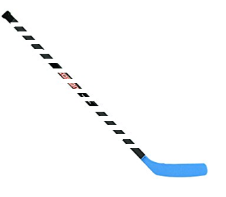
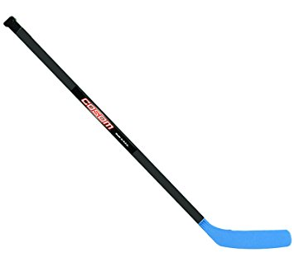
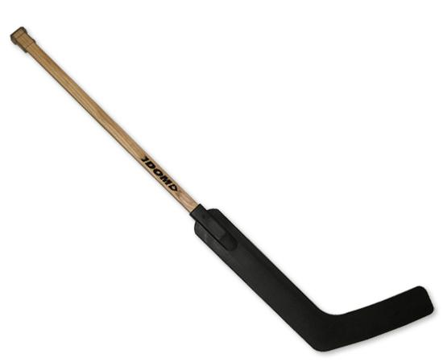
Goalie Stick

Offense/Defensive Stick
Center Stick

Court Size
- The playing area shall be a maximum of 40 feet by 80 feet long (basketball court dimensions) on a level surface and properly marked for poly hockey. If the playing area is smaller than 40 feet by 80 feet, appropriate adjustments in the court dimensions may be made. Higher level games could extend up to 90 feet.
- A center line will mark the area of play such that the floor is divided into equal halves. These halves constitute the offensive and defensive zones for each team. The mid-court line of the basketball court can serve as the center line.
- Center Circle Spot: A circular spot 4 inches in radius to be marked in the center of the center floor face-off circle.
- Face-Off Circles: A circle with a radius of 36 inches and a line width of 2 inches to be marked outside the center circle spot. (All line widths are 2-inch floor tape)
- Goals: The back of the goals will be set 4 feet out from the midpoint of the end lines, and the front of the goals will sit on a goal line of 2 inches width between the two goal posts at each goal. The two goals will be set equidistant from each side of the playing area.
- Goal Crease: The goal crease is made of restraining lines drawn 5 feet from the goal line toward center circle and 4 feet out from each side of the goal. Goal Dimensions: Goals must be of uniform dimensions. The goals used at SOMI. Culminating Events will be 5 feet wide x 4 feet high and 2 feet deep.
- Goal posts on dotted lines drawn at 45-degree angles to the goal line, starting at the goal posts. Face-off circles will be 3 feet in radius. Modifications may be made based on the size of the facility.
- Four face-off circles, two in each half of the court, shall be marked off. The center points of these four face-off circles shall be located 13 to 23 feet from the goal posts on dotted lines drawn at 45-degree angles to the goal line, starting at the goal posts. Face-off circles will be 3 feet in radius. Modifications may be made based on the size of the facility.

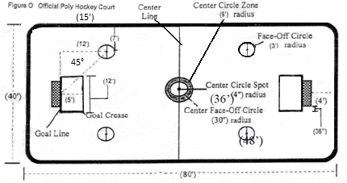

Time of Play
- The clock starts with the referee's whistle at the beginning of the game and after each stoppage of play. The clock will stop when: (a) a goal is scored or (b) any type of foul is called. The clock will resume within 15 seconds. Only the referee may stop the clock for a greater amount of time when there is an injury, medical problem, or substitution.
- Play starts from the center circle at the start of a period and after a goal, unless play is stopped because of an infraction, or when an infraction occurs at the end of a period, the resulting face-off will be held in the offending team's defensive circle. All other face-offs (i.e. after injury, after the mandatory three-minute stoppage, etc.) will be held at the center circle.
- When the game is played in gyms where the puck can go out of play or under bleachers, etc., officials will carry extra pucks and will drop one at the point closest to where the puck went out of play; thus, play should be continuous.
- A puck that deflects off the referee will remain in play.
- Each team will be allowed one time-out per game. This time-out will be one minute in duration. No additional time-outs are awarded in overtime periods.
- Each line will consist of two defensive players, two forwards, and one center.
- Substitutions may occur at any stoppage of play but must be waved in by a referee.
- Play will start or stop only with the sound of the referee's whistle.
- A change of position between defensive and offensive players can be made at any stoppage of play and after notifying the referee.
- Mercy rule – once a team is ahead by a certain number of goals (to be determined by the tournament director) the clock will be a running clock.

Face-Offs
- The puck will be placed flat in the center of the face-off circle. A player from both teams will place the blades of their sticks 2 inches back from the puck. At the sound of the whistle, the players play the puck for possession.
- Any face-off taken in the center face-off circle must be played only by the center of each team.
- All players not involved in the face-off must be stationary and outside of the face-off circle during the face-off.

Scoring
- A goal will be scored anytime the puck completely breaks the vertical plane. Each goal is worth one point.
- The puck can deflect off a player or piece of equipment accidentally into the goal to be considered a goal.
- The puck cannot be kicked or thrown into the goal by an offensive player.
- The puck must be completely in the goal to be considered a goal; A puck resting on the goal line shall not be considered a goal.
- Any vertical or horizontal movements with the puck to score a goal will not score a goal.
- A goal cannot be scored on an offensive foul or with an offensive player or his/her stick in the goal crease.
- If a defensive player is in the goal crease when a goal is scored, the goal will count, and a foul will be called on the defensive player. This is considered a delayed foul.
- A goal will be scored if the puck is put into the goal in any way by a defending player during the game.
- In order for a goal to count, the puck needs to be in the goal before the referee's signal sounds.
- A goal can be scored from a face-off in any location.

Goalkeeping
- The goalkeeper may use his/her hands or stick to clear the puck away from the goal or out of the goal crease.
- A dotted line will extend from the goal pipe at a 45-degree angle to the side face-off circles. The goalkeeper may sweep or toss the puck in an underhand manner behind these lines. The goalkeeper may shoot the puck in any direction, without the 45-degree restriction, with his/her stick, but must remain in the crease to do so.
- The goalkeeper cannot hold the puck for more than three seconds.
- The goalkeeper must start in a standing position. This means not kneeling or sitting, but with both feet flat on the court.
- The goalkeeper may go down in front of the goal to make a save but may not remain on the ground in front of the goal for more than three seconds.
- The goalkeeper must remain in contact with the crease when playing the puck.
- A goalkeeper can be removed from the game at any time during a normal stoppage of play. The replacement player can play defense or forward positions. They may not be a center. The goalkeeper may return to the game, replacing the substitute who was originally substituted for him/her at a normal stoppage of play.

Minor Fouls
- Minor fouls result in the referee stopping play. Play is resumed with a face-off in the offending team's defensive circle.
- In certain minor fouls, a delayed penalty may be called. When a delayed penalty occurs, the referee raises his/her hand into the air to signal a delayed penalty. The foul that resulted in the delayed penalty will not be called until the team on defense at the time of the foul takes possession of the puck, advances the puck, or a goal is scored against the defending team.
- Minor fouls occur in the following instances:
  - When a player wears jewelry or hard hair ornaments outside the helmet.
  - When a player enters the game with an illegal uniform or equipment.
  - When a player deliberately holds, lies on, or steps on the puck.
  - When a goalkeeper contacts the puck when he/she is not in contact with the crease.
  - When a goalkeeper uses an overhand throw, clears or throws the puck to the center side of the dotted line coming out 45 degrees for the goal posts of his/her goal (delayed penalty).
  - When a goalkeeper is pulled and the puck stops within the crease, a foul is charged to the goalkeeper. Resulting play starts from the defensive circle.
  - When a forward or defensive player crosses the center court line (delayed penalty).
  - When a player does not remain stationary during the face-off.
  - When a player other than the goalkeeper deliberately leaves his/her feet to block a pass or shot (delayed penalty).
  - When an offensive or defensive player and/or his/her stick (other than goalkeeper) goes into the goal crease at any time. A delayed penalty will be called when defensive players violate this rule.
  - When a goalkeeper does not attempt to stand within three seconds after going down onto the floor to make a save (delayed penalty). A goalkeeper is considered down if they are kneeling or sitting.
  - When high sticking takes place. This foul occurs when a player raises his/her stick above his/her waist.
  - When any deliberate roughness takes place.
- A player will receive a two-minute expulsion after accumulating five minor fouls.

Major Fouls
- Major fouls result in a power play and two-minute expulsion of the offending player or a line captain in the case of a bench penalty. Your center at the time of the bench penalty is considered your line captain. The coach may assign another player on that line to take the center's vacated position during the penalty. The two-minute penalty is discontinued if the opposing team scores a goal and 5 vs. 5 play continues.
- Major fouls occur in the following instances:
  - When a player charges an opponent from behind or trips or intentionally pushes an opponent.
  - When a player crosschecks an opponent (i.e. holding the stick in a horizontal plane away from the body to check an opponent).
  - When any excessive roughness takes place.
  - When a player accumulates 5 minor fouls.
  - When elbowing takes place.
  - When a bench penalty takes place.
  - When unsportsmanlike conduct by players, coaches, and spectators (i.e. swearing, verbally challenging an opponent, etc.) takes place.
- Any player who commits two major fouls shall immediately be ejected from the game.

Ejection Penalty
- A player or coach who commits an act that results in the ejection penalty must leave the building for the remainder of the game. Spectators are an extension of your team and will be asked to leave if their behavior merits ejection.
- Ejections occur in the following instances:
  - When a player deliberately does anything that could cause injury or harm to another player.
  - When a coach's misconduct becomes detrimental to the players and the game. If, after an ejection, the coach's misconduct continues, the game will be forfeited.
  - When a player or coach intentionally throws or swings a stick.
  - When a player commits two major fouls.
  - When a player commits ten minor fouls.
  - When a player is ejected from a game, a teammate serves the two-minute penalty. A substitute may be entered for the ejected player after the penalty has been served.
- A coach may lodge a protest for an interpretation of the rules except if it is a referee's judgment call.

Individual Skills Contest
The Individual Skills Contest is designed for lower ability athletes who have not yet developed the skills necessary to participate meaningfully in team competition. Athletes may not be assisted by coaches or chaperones. Modifications will be made for blind and hearing-impaired athletes

Event #1 - Shoot Around the Goal
- Purpose: To evaluate the athlete's shooting accuracy and power as well as the athlete's ability to score goals from any angle, given a time constraint.
- Equipment: Poly hockey stick, 5 pucks, tape and a goal
- Description: Athlete takes one shot from five different spots around the goal. These spots are located at the end points of five 6-meter rays, which start from a common point. Each ray is drawn such that it creates a 30-degree angle with the goal line or with a previously-drawn ray. An athlete has a 30 second time limit to shoot all the pucks. One puck shall be at each spot before the athlete starts. (See Figure P)
- Scoring: Each puck that completely crosses the goal line into the goal is worth five points. The score is the total of the five shots with 25 points maximum.

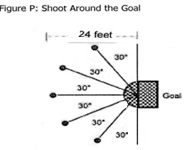

Event #2 - Pass
- Purpose: To evaluate the athlete's control and accuracy when passing the puck.
- Equipment: Poly hockey stick, puck, tape and traffic cones.
- Description: Athlete makes five passes from behind a line. Athlete tries to pass the puck between two cones 4 feet apart that are placed 32 feet from the passing line.
- Each time the puck passes completely across the line between the two cones, the athlete shall be awarded five points. If the puck hits the cone, but still passes through the cones, the athlete shall be awarded three points. The athlete's total score is the sum of the five passes with 25 points maximum.
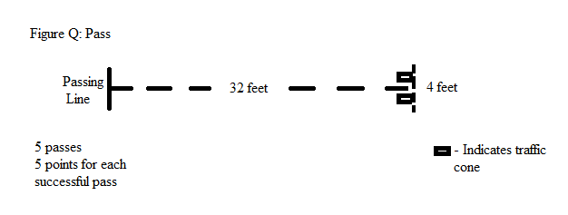

Event #3 - Stick Handling
- Purpose: To evaluate the athlete's speed and ability to handle the puck.
- Equipment: Poly hockey stick, puck, 6 traffic cones, tape and a goal.
- Description: Athlete stick handles the puck from a starting line through a course defined by cones and shoots the puck at the goal. The distance from the start line to goal line shall be 21 meters. The cones shall be placed in a straight line at intervals of 3 meters. The clock stops when the puck passes the goal line.
- The time spent stick handling is subtracted from 60. If any cones are missed, one point is subtracted for each miss. Five bonus points are given if the athlete scores a goal.

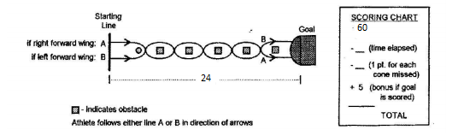

Event #4—Shoot for Accuracy
- Purpose: To evaluate the athlete's accuracy, power and ability to score by shooting the puck into specific areas of the goal.
- Equipment: Poly hockey stick, puck, goal and tape or rope.
- Description: Athlete takes five shots from behind a line that is five meters from and directly in front of, the goal. Six sections are defined within the goal by rope or tape as shown in the diagram. The vertical rope or tape is hung 45 cm (18") in from each goal post. The horizontal rope or tape is strung 30 cm (12") above the floor. (See Figure S)
- Scoring: The goal is divided into point sections as follows:
- 5 points for any shot entering the goal in either of the upper corners.
- 3 points for any shot entering the goal in either of the lower corners.
- 2 points for any shot entering the goal in the upper middle section.
- 1 point for any shot entering the goal in the lower middle section.
- 0 points for any shot not entering the goal
